

October 19, 2022

**TO WHOMSOEVER IT MAY CONCERN**

This is to certify that Suryadevi A (Emp id. 14829) has been working with us since September 03, 2018 and designated as “Senior Associate - 3B2”.

She has resigned her services on June 15, 2022 which has been accepted by us. We relieved her from the services of our company effective the closing hours of July 21, 2022.

We record our appreciation for the services rendered by her and wish her all the best in her future endeavours.

**Regards,**

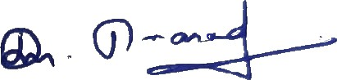

**Prasad D**

**Assistant Vice President – Human Resources**

**TNQ Technologies Private Limited** (Formerly known as TNQ Software Private Limited)

4/600, Phase ıı, Dr. Vikram Sarabhai Instronic (VSI) Estate, Kottivakkam, Thiruvanmiyur, Chennai 600 041, INDIA

**P** +91 44 4596 4800 **F** +91 44 45964899 **E** [info@tnq.co.in](mailto:info@tnq.co.in) **W** [www.tnq.co.in](http://www.tnq.co.in/) CIN: U72900TN2010PTC077050